Grade 7 Accelerated · Unit 3  Unit 3 Review  Exponents and Scientific Notation | Name______________________  Date______________________  Period____________________

Show your work. Circle your final answer.
HOW TO USE THIS. This review covers every learning target from the unit — more than the assessment does. Work it in parts. If you miss two or more in a part, that part is where to spend your study time. The reference sheet has everything you need for each part.
PART A. Product, Quotient and Power Laws Lessons 1–3 · 8 questions
1. Write as a single power: 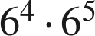

2. Write as a single power: 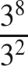

3. Write as a single power: 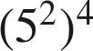

4. Find the value: 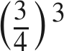

5. Find the value: 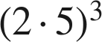 and 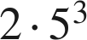. Are they equal?

6. Find the value: 

7. Find the value of : 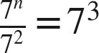

8. Which expression is equivalent to 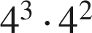 ?
○ A. 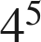
○ B. 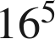
○ C. 
○ D. 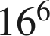

PART B. Zero and Negative Exponents Lessons 4–5 · 7 questions
9. Rewrite with a positive exponent: 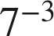

10. Rewrite with a positive exponent: 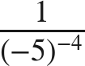

11. Find the value: 

12. Find the value: 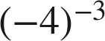

13. Find the value: 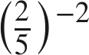

14. Find the value: 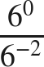

15. Find the value of : 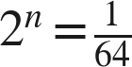

PART C. Evaluating and Equivalent Expressions Lessons 6–7 · 5 questions
16. Find the value: 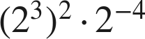

17. Find the value: 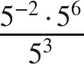

18. Every part below is about the expression 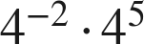.
a. Write it as a single power.

b. Find its value.

c. Is it equivalent to 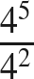 ? Explain.

d. Find so that 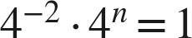.

19. Select ALL of the expressions equivalent to 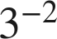.
□ A. 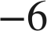
□ B. 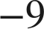
□ C. 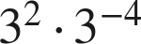
□ D. 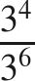
□ E.
□ F. 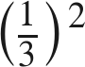

20. Aryella says that  and 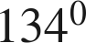 are equal. Is she right? Explain.

PART D. Variable Bases Thread A, days 1–2 · 8 questions
21. Write as a single monomial: 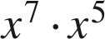

22. Write as a single monomial: 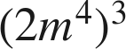

23. Write as a single monomial: 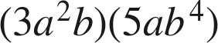

24. Write as a single monomial: 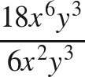

25. Rewrite with positive exponents only: 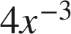

26. Rewrite with positive exponents only: 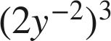

27. Rewrite with positive exponents only: 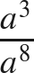

28. Which expression is equivalent to 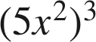 ?
○ A. 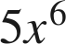
○ B. 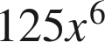
○ C. 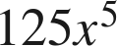
○ D. 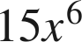

PART E. Large Numbers in Scientific Notation Lesson 8 · 5 questions
29. Write 7,400,000 in scientific notation.

30. Write 205,000,000,000 in scientific notation.

31. Write 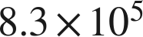 in standard form.

32. How many times larger is  than 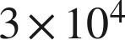 ?

33. Dana writes 45,000 as 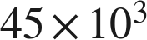. Is her expression equal to 45,000? Is it scientific notation? Explain.

PART F. Small Numbers, and How Many Times Lesson 9 · 6 questions
34. Write 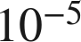 as a decimal.

35. Write 0.00093 in scientific notation.

36. Write 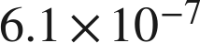 in standard form.

37. Which is greater, 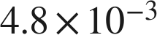 or 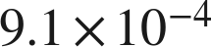 ? Explain.

38. How many times larger is 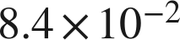 than 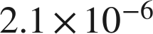 ?

39. A computer displays a number as 2.7E−5. Write it in scientific notation and in standard form.

